**Information Gathering Projects :Vulnerability Assessment**

* **Introduction:**

This documentation encapsulates my extensive work in the field of vulnerability assessment, showcasing a comprehensive exploration of security weaknesses and their mitigation strategies. Through these projects, I have delved into various methodologies and tools to identify and analyze potential vulnerabilities across different systems and networks. My documentation is meticulously structured, highlighting the processes, tools, and findings, while also providing insights into best practices for securing digital environments.

* **Prevention of Information:**

**1.Project Overview:**

* **Objective**: Clearly state the purpose of the project.

(e.g., "The objective was to identify vulnerabilities in a network environment").

* **Scope**: Define the boundaries of the assessment, specifying what is included and excluded.

**2. Detailed Steps in Information Gathering:**

* **Passive Reconnaissance**: Document tools used and the type of data gathered without disclosing specific sensitive information.
* **Active Reconnaissance**: Include methodologies (e.g., Nmap scanning) and types of information gathered.

**3. Vulnerability Identification:**

* **Documenting Vulnerabilities**: For each vulnerability, include:

DNS Servers, AAAA, IPV4/V6, Host Location, etc.

* **Project Reports:**

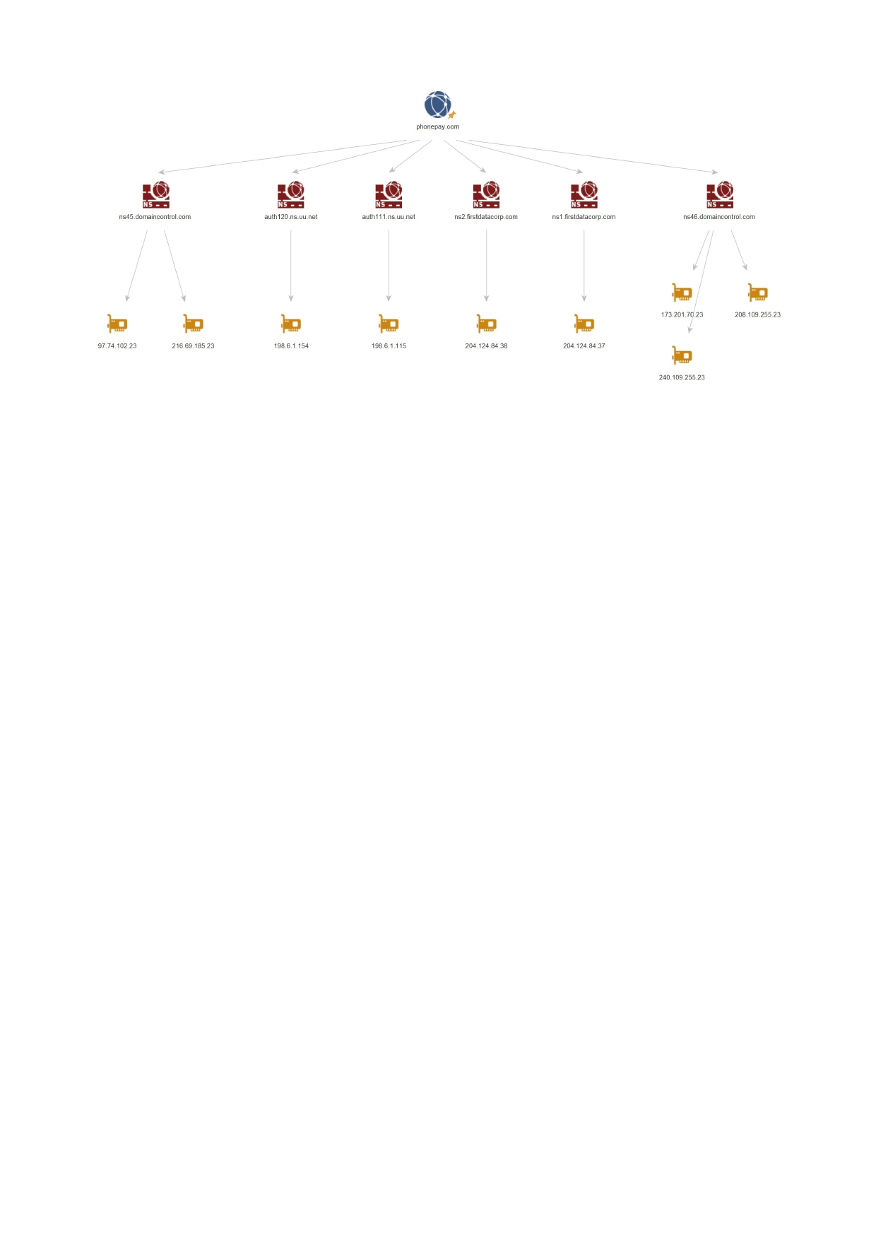

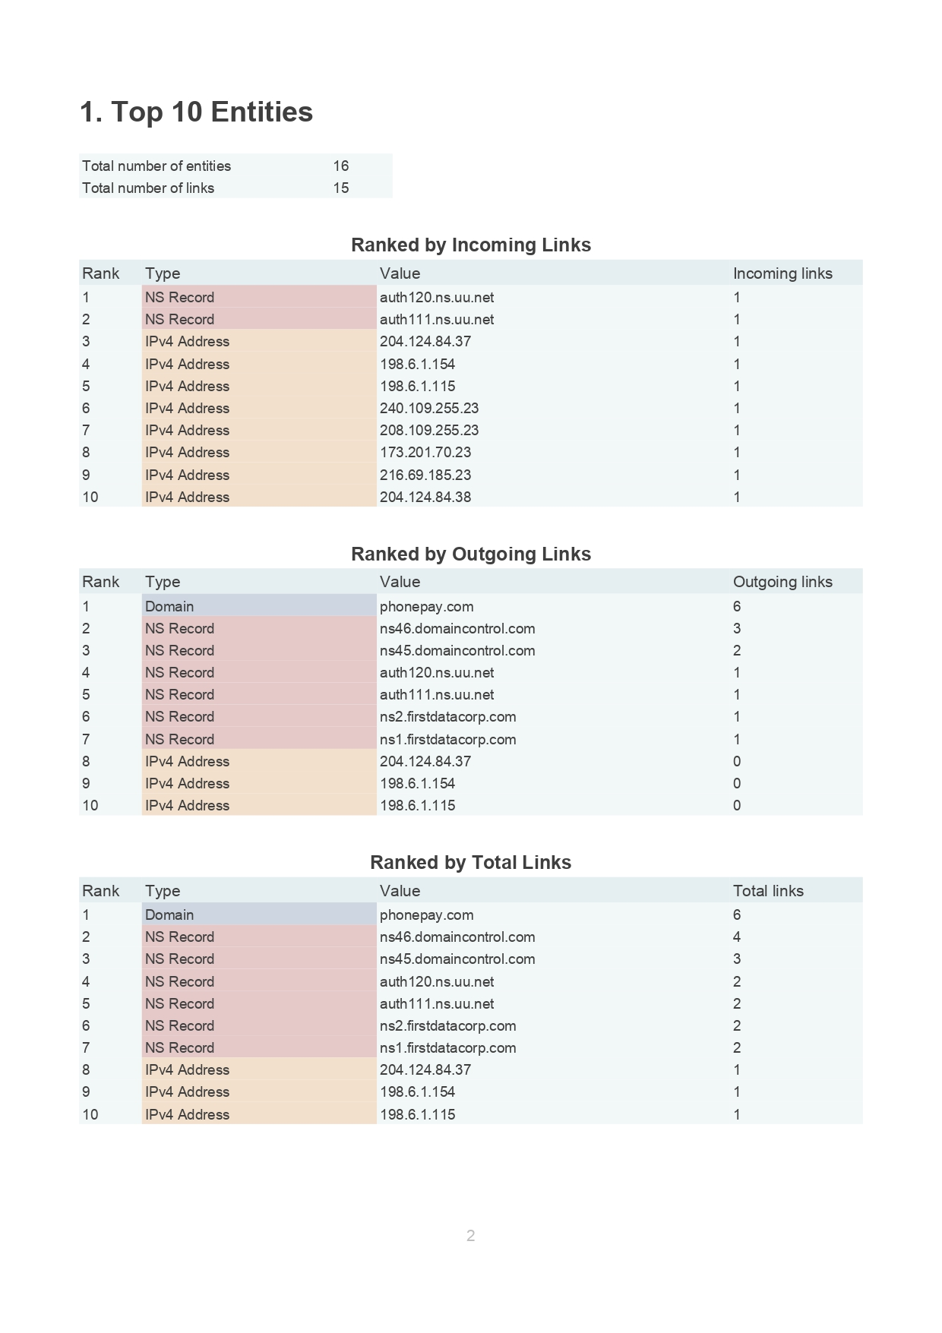

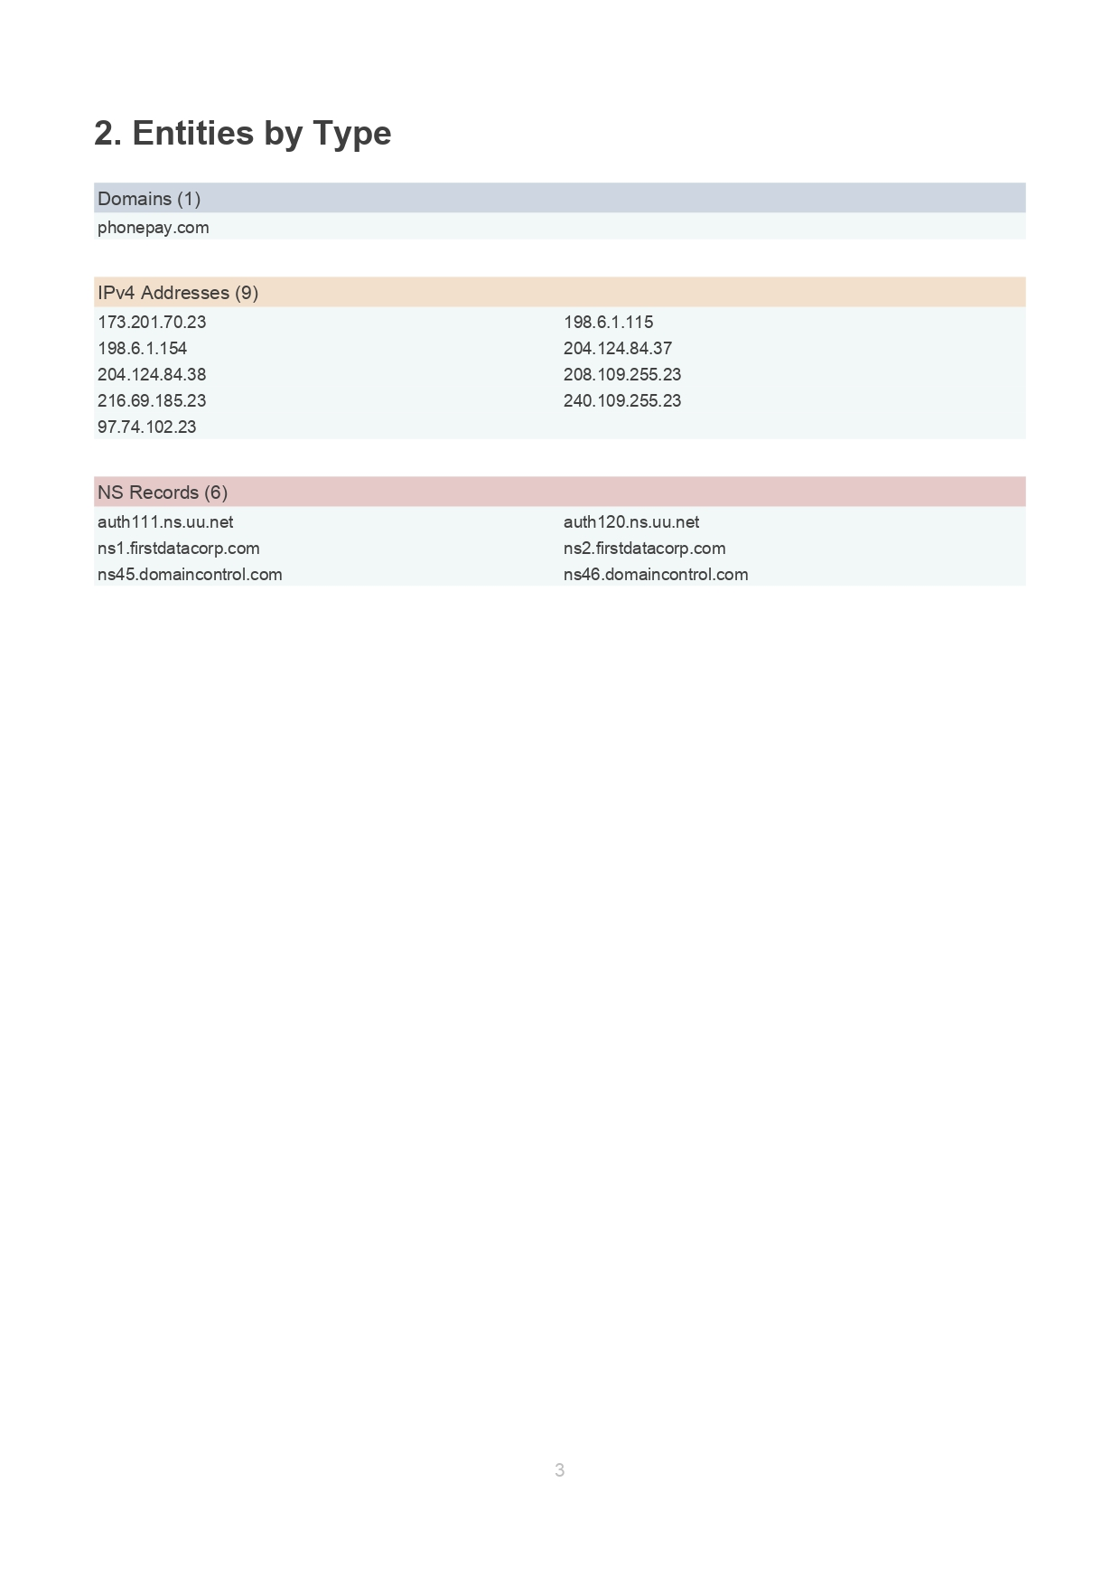

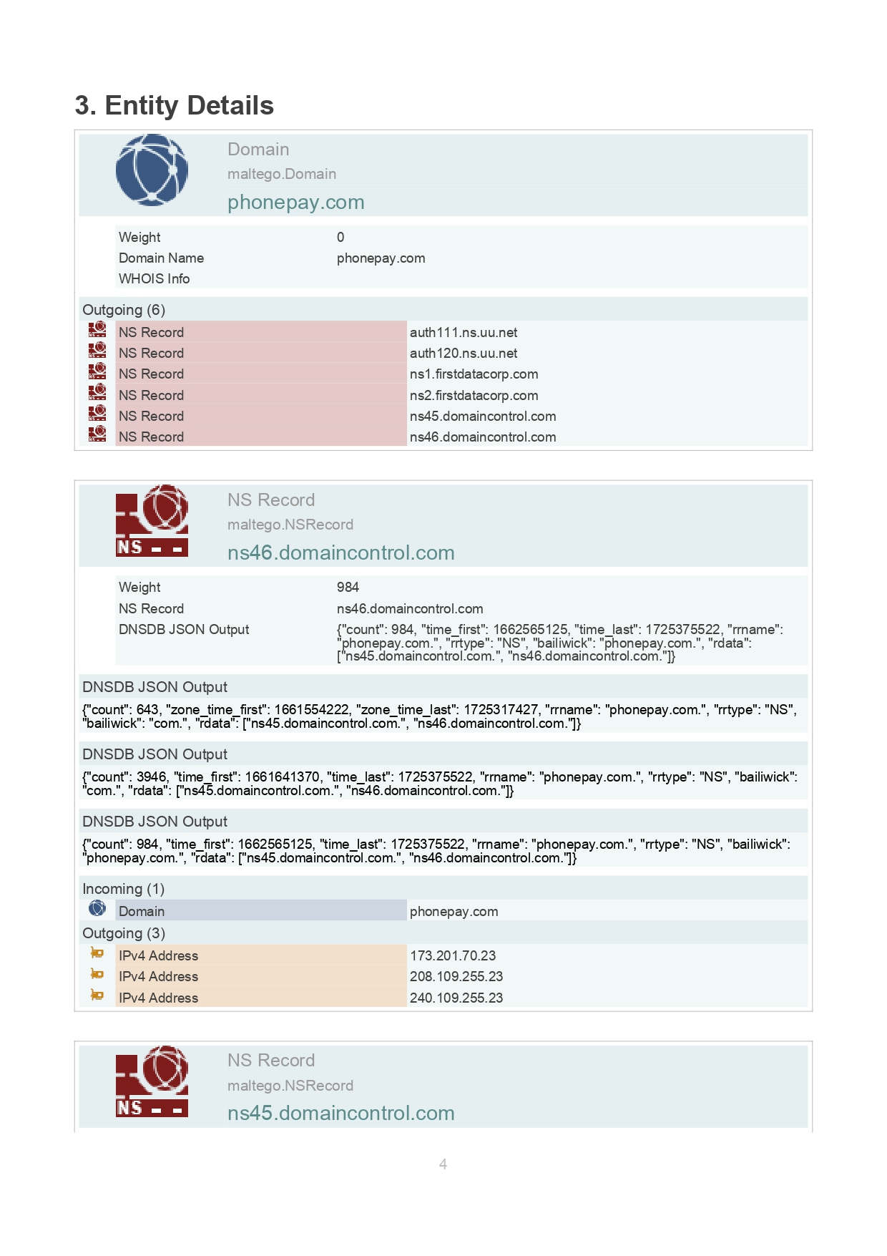

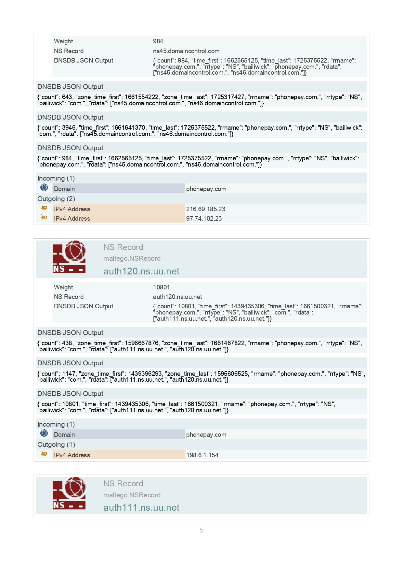

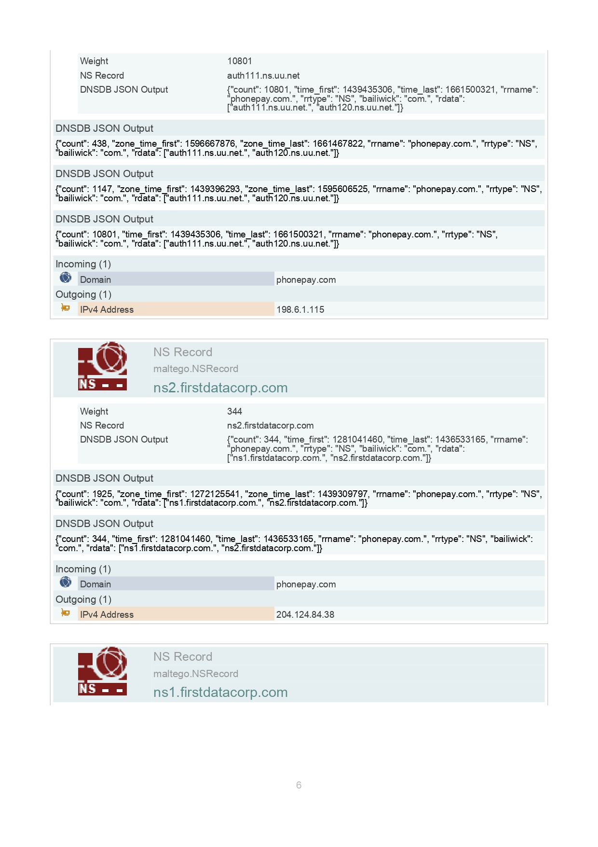

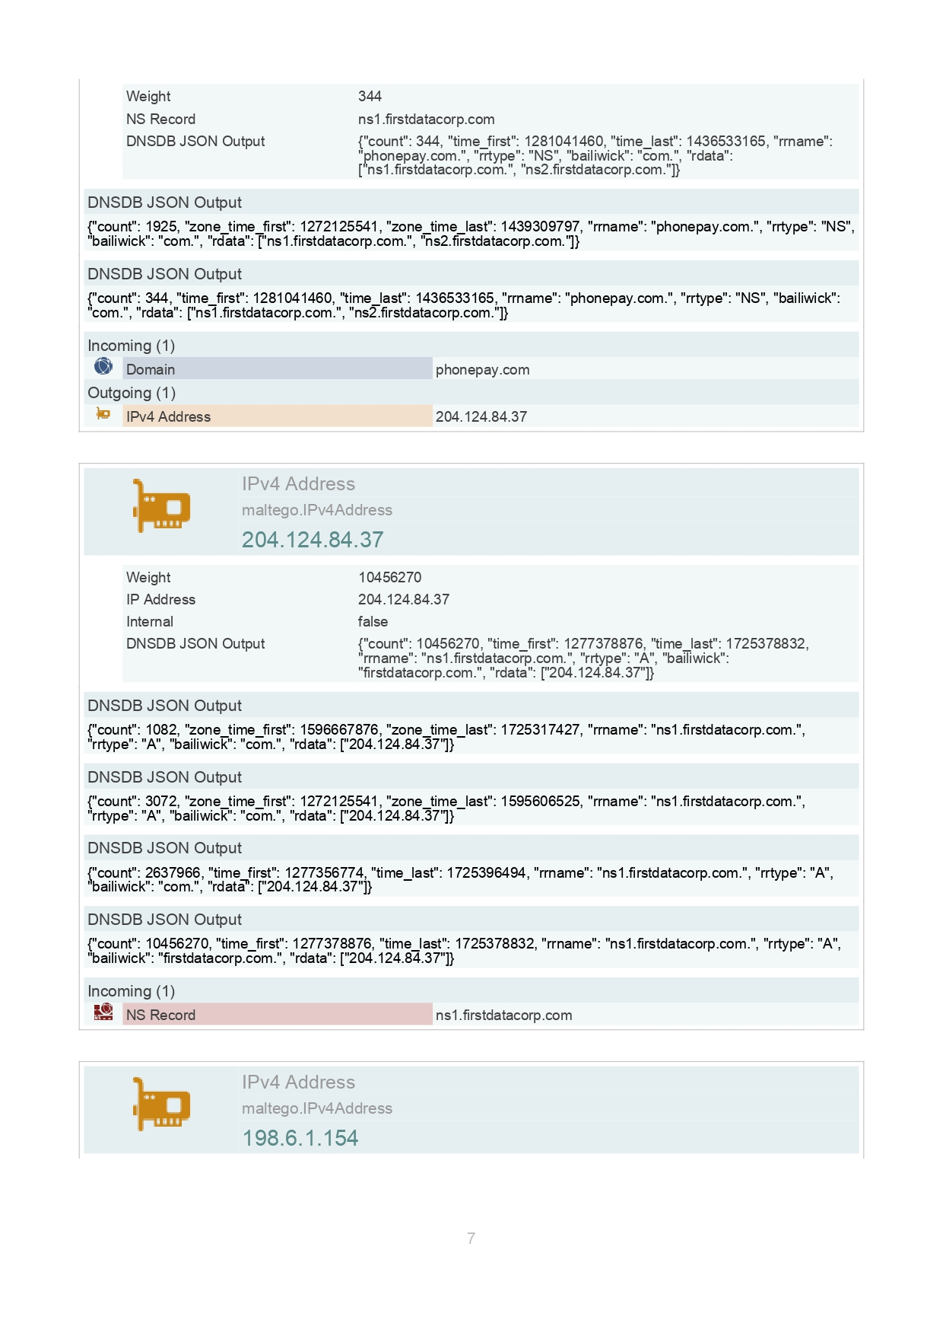

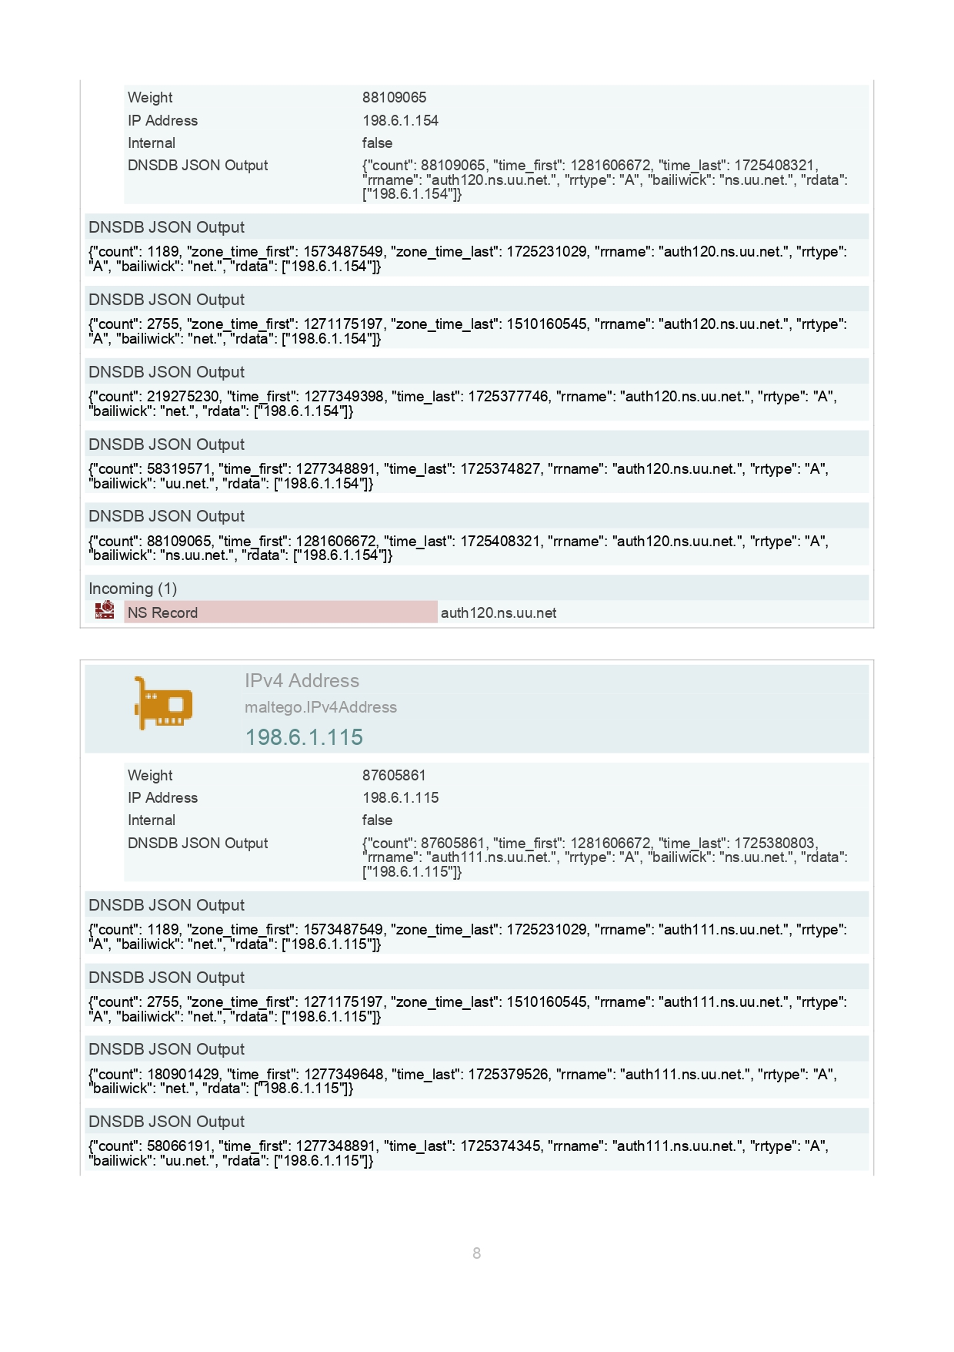

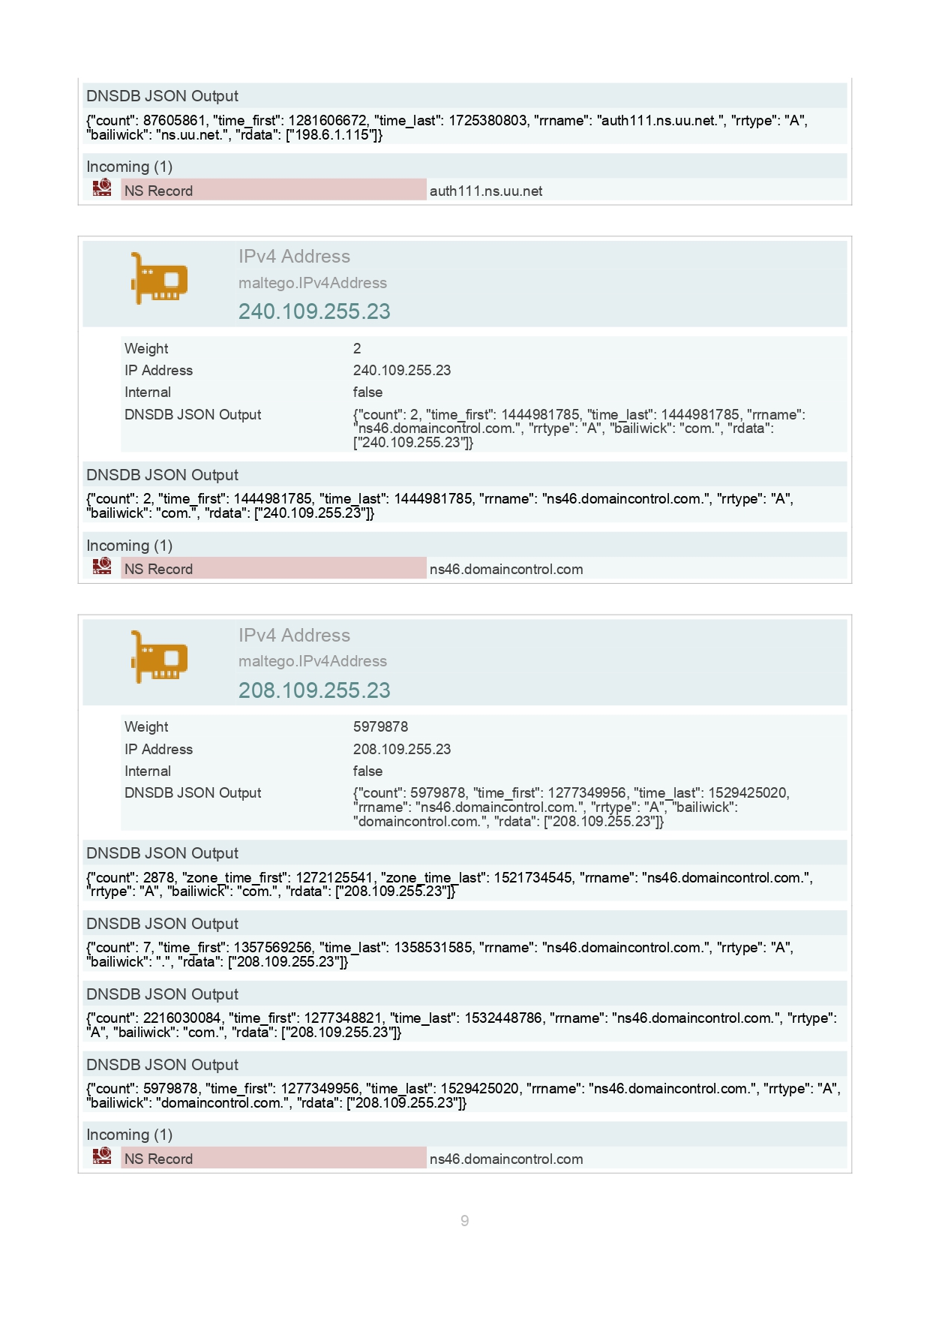

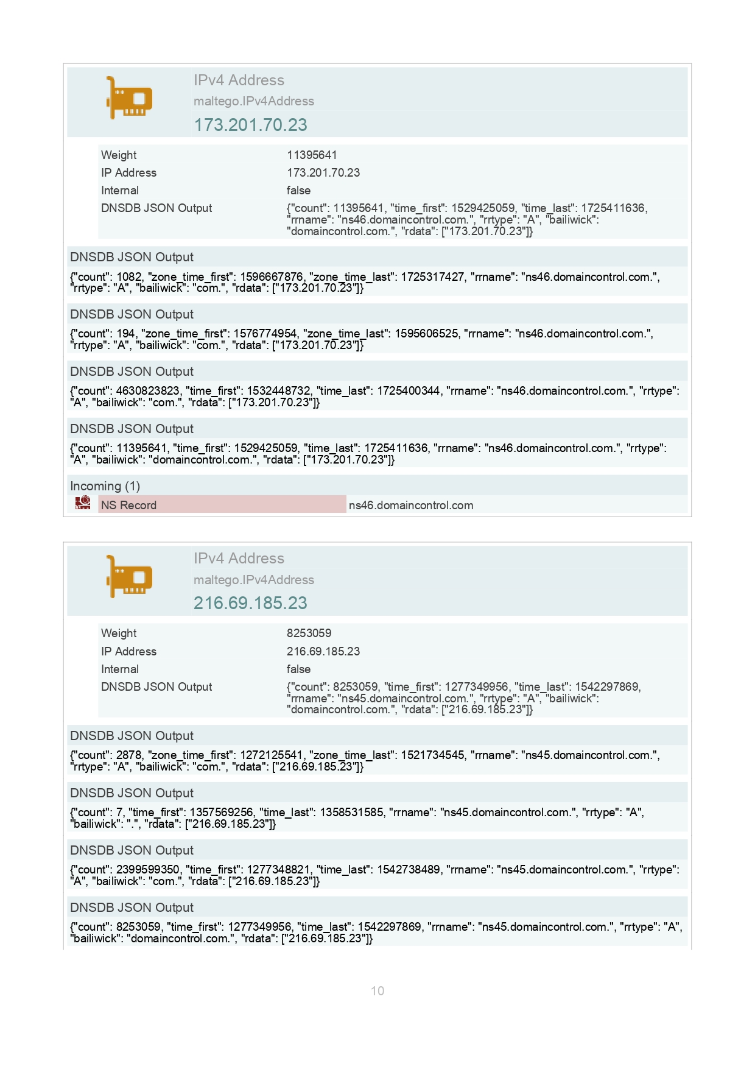





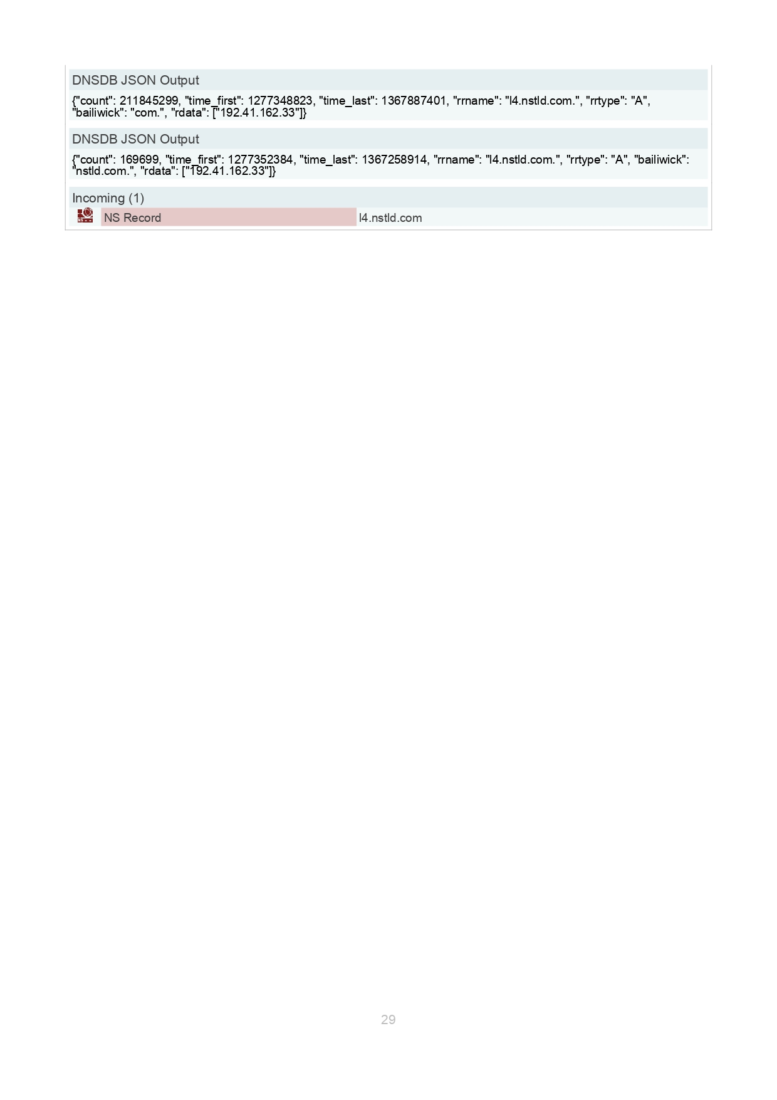

* **Conclusion:**

The vulnerability assessments conducted throughout this project have demonstrated a comprehensive understanding of network security, threat identification, and risk management. Each phase, from initial reconnaissance to detailed exploitation, was meticulously planned and executed to uncover potential weaknesses within the target systems. By employing a range of advanced techniques, such as automated scans, manual testing, and custom scripting, I was able to gather critical data that highlighted both existing vulnerabilities and potential vectors for compromise.

This assessment not only revealed several key vulnerabilities but also provided actionable insights into how these could be mitigated effectively. Recommendations included patch management, configuration hardening, and the implementation of enhanced security protocols. Furthermore, the project underscored the importance of a proactive security posture, emphasizing regular audits and the adoption of a layered defense strategy to safeguard against emerging threats.

In conclusion, the documentation reflects a robust and systematic approach to vulnerability assessment, serving as a valuable resource for improving security measures and preventing future breaches. This project has solidified my expertise in penetration testing and reinforced my commitment to fostering secure and resilient cyber environments.